fileurl<-"https://d396qusza40orc.cloudfront.net/exdata%2Fdata%2Fhousehold_power_consumption.zip"

download.file(fileurl,destfile=paste0(getwd(),"/Power_consumption.zip"),method = "curl")

unzip("Power_consumption.zip",exdir="./")

Read first 5 rows to get headers

initial<-read.table("household_power_consumption.txt", header=TRUE,sep=";", nrows=5)

Read 2900 rows that contain information on 2007-02-01 and 2007-02-02

hpc<-read.table("household_power_consumption.txt", header=TRUE,sep=";", skip=66630,

nrows=2900, col.names=names(initial), na.strings=c("?"),

colClasses=c("character", "character","numeric","numeric","numeric","numeric",

"numeric","numeric","numeric"))

Converting Date and Time variables to Date/Time format

hpc$Date<-as.Date(hpc$Date, format = "%d/%m/%Y")

hpc$Time<-strptime(paste(hpc$Date,hpc$Time),"%F %T")

Subsetting loaded data for 2007-02-01 and 2007-02-02

hpc<-subset(hpc,hpc$Date %**in**% as.Date(c("2007-02-01","2007-02-02")))

Creating plots

Overall goal here is to examine how household energy usage varies over a 2-day period in February, 2007. Every plot is recreated for the second time in order to save it to png file without being corrupted by *dev.copy()* function.

Plot 1. Histogram of Global active pover consumption

par(mfrow=c(1,1),mar=c(5,4.5,4,2))

hist(hpc$Global_active_power, col="red", main="Global Active Power",

xlab="Global Active Power (kilowatts)")

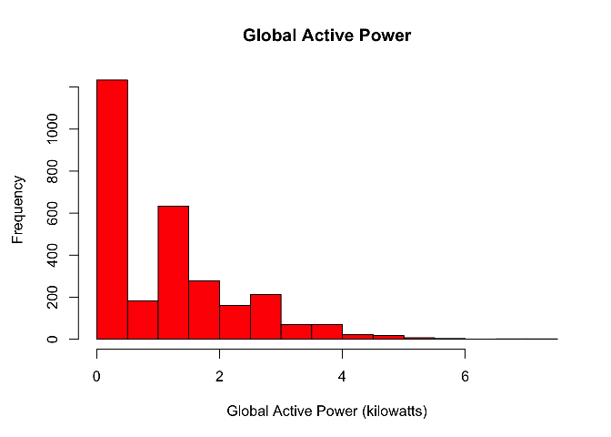

png("plot1.png", width=480, height=480)

par(mfrow=c(1,1),mar=c(5,4.5,4,2))

hist(hpc$Global_active_power, col="red", main="Global Active Power",

xlab="Global Active Power (kilowatts)")

dev.off()

## quartz_off_screen

## 2

#### Plot 2. Global active pover consumption over time

par(mfrow=c(1,1),mar=c(5,4.5,4,2))

plot(hpc$Time,hpc$Global_active_power, ylab="Global Active Power (kilowatts)",

xlab="", pch =".", type="l")

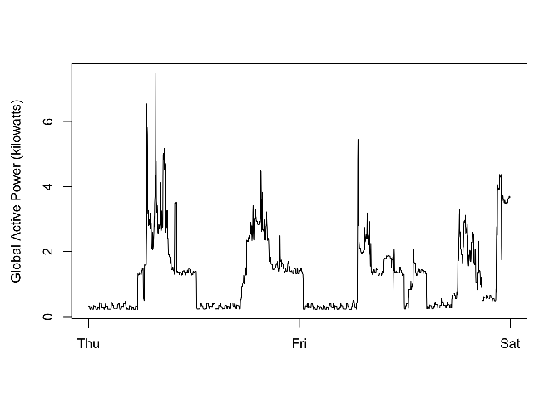

png("plot2.png", width=480, height=480)

par(mfrow=c(1,1),mar=c(5,4.5,4,2))

plot(hpc$Time,hpc$Global_active_power, ylab="Global Active Power (kilowatts)",

xlab="", pch =".", type="l")

dev.off()

## quartz_off_screen

## 2

#### Plot 3. Energy sub meterings

par(mfrow=c(1,1),mar=c(4,4,4,2))

plot(hpc$Time,hpc$Sub_metering_1,ylab="Energy sub metering", xlab="", type="l", col="black")

points(hpc$Time,hpc$Sub_metering_2, col="red", type="l")

points(hpc$Time,hpc$Sub_metering_3, col="blue", type="l")

legend("topright", lwd=1, col=c("black", "red", "blue"), legend=names(hpc[,7:9]))

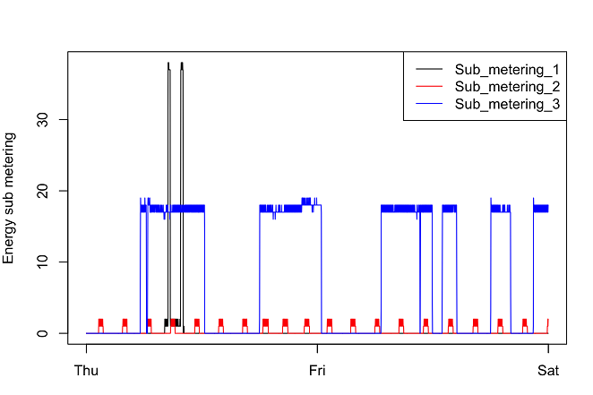

png("plot3.png", width=480, height=480)

par(mfrow=c(1,1),mar=c(4,4,4,2))

plot(hpc$Time,hpc$Sub_metering_1,ylab="Energy sub metering", xlab="", type="l", col="black")

points(hpc$Time,hpc$Sub_metering_2, col="red", type="l")

points(hpc$Time,hpc$Sub_metering_3, col="blue", type="l")

legend("topright", lwd=1, col=c("black", "red", "blue"), legend=names(hpc[,7:9]))

dev.off()

## quartz_off_screen

## 2

#### Plot 4. Combination of 4 plots: global active power, energy sub meterings, voltage over time, global reactive power over time

par(mfcol=c(2,2), mar=c(4.5,5,2,2))

*# Plot 4.1*

plot(hpc$Time,hpc$Global_active_power, ylab="Global Active Power (kilowatts)",

xlab="", pch =".", type="l")

*# Plot 4.2*

plot(hpc$Time,hpc$Sub_metering_1,ylab="Energy sub metering", xlab="", type="l", col="black")

points(hpc$Time,hpc$Sub_metering_2, col="red", type="l")

points(hpc$Time,hpc$Sub_metering_3, col="blue", type="l")

legend("topright", lwd=1, col=c("black", "red", "blue"), legend=names(hpc[,7:9]), bty="n")

*# Plot 4.3*

plot(hpc$Time,hpc$Voltage, ylab="Voltage", xlab="datetime", type="l")

*# Plot 4.4*

plot(hpc$Time,hpc$Global_reactive_power, ylab="Global_reactive_power", xlab="datetime", type="l")

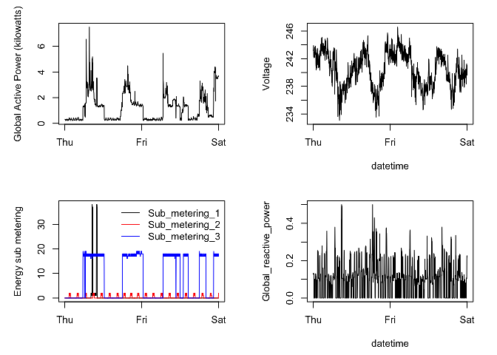

png("plot4.png", width=480, height=480)

par(mfcol=c(2,2), mar=c(4.5,5,2,2))

*# Plot 4.1*

plot(hpc$Time,hpc$Global_active_power, ylab="Global Active Power (kilowatts)",

xlab="", pch =".", type="l")

*# Plot 4.2*

plot(hpc$Time,hpc$Sub_metering_1,ylab="Energy sub metering", xlab="", type="l", col="black")

points(hpc$Time,hpc$Sub_metering_2, col="red", type="l")

points(hpc$Time,hpc$Sub_metering_3, col="blue", type="l")

legend("topright", lwd=1, col=c("black", "red", "blue"), legend=names(hpc[,7:9]), bty="n")

*# Plot 4.3*

plot(hpc$Time,hpc$Voltage, ylab="Voltage", xlab="datetime", type="l")

*# Plot 4.4*

plot(hpc$Time,hpc$Global_reactive_power, ylab="Global_reactive_power", xlab="datetime", type="l")

dev.off()

## quartz_off_screen

## 2